**IOT PROJECT**

**Adaptive Traffic Light**

| **21BCE2341** | **KRISHNA AGARWAL** |
| --- | --- |
| **21BCE2363** | **KAMIL DEHLIWALA** |
| **21BCE3147** | **DHRUV KHANNA** |

Submitted to

| **Dr Yokesh Babu S** |
| --- |
| Associate Professor Grade 1 |
| School of Computer Science and Engineering (SCOPE) |

**B.Tech.**

*in*

**Computer Science and Engineering**

**School of Computer Science and Engineering**

**Index**

| **Title** | **Page no** |
| --- | --- |
| **Abstract** | **1** |
| **Introduction** | **1** |
| Background | **1** |
| Objective | **1** |
| Literature Review | **1** |
| **Methodology** | **2** |
| System architecture | **2** |
| Signal Switching Algorithm | **3** |
| Simulation Module | **3** |
| Algorithm | **4** |
| **Result** | **5** |
| Experimental Setup | **5** |
| Results | **5** |
| Limitations | **5** |
| **Conclusion** | **6** |
| Future Work | **6** |
| **Images** | **7** |
| Vehicle Detection Module | 8 |
| Simulation module | 12 |
| Model Simulation | 14 |
| **Code Explanation** | **17** |
| **Adaptive Timer Code** | **19** |
| **References** | **20** |

# **Traffic Optimisation Using an Adaptive Traffic Light Control System**

## **Abstract**

Traffic congestion is a growing problem in urban areas, leading to delays, increased fuel consumption, and environmental pollution. This paper presents an Adaptive Traffic Light Control System (ATLCS) that leverages real-time data and machine learning algorithms to optimize traffic signal timings dynamically. The system uses a combination of sensors, cameras, and IoT technologies to collect traffic data and adjust light cycles based on traffic density and flow. Experimental results show significant reductions in waiting times and fuel consumption, demonstrating the system's potential to improve urban traffic management.

## **1. Introduction**

### **1.1 Background**

Urbanization has led to a surge in vehicular traffic, causing congestion at intersections controlled by traditional traffic lights with fixed timers. These systems are unable to respond dynamically to real-time traffic conditions, resulting in inefficiencies.

### **1.2 Objective**

The objective of this project is to design and implement an Adaptive Traffic Light Control System that:

1. Monitors real-time traffic conditions.
2. Dynamically adjusts signal durations.
3. Reduces congestion, fuel consumption, and waiting times.

### **2. Literature Review**

Adaptive Traffic Signal Control Systems (ATSCS) represent a pivotal advancement in urban traffic management, leveraging real-time data and intelligent algorithms to optimize signal timings. A review of existing research highlights diverse approaches and their potential impact. One study emphasizes the use of multi-agent reinforcement learning (MARL) in self-adaptive systems, showcasing its ability to integrate with vehicle-to-everything (V2X) communication for dynamic adaptability. However, its focus remains largely conceptual, with limited applicability in regions facing infrastructural constraints. Another study explores the SURTRAC system, a decentralized schedule-driven approach that optimizes individual intersections and reduces travel time and emissions, yet its scalability beyond small networks remains untested. A comprehensive review of AI techniques further highlights methods like deep reinforcement learning (DRL) and fuzzy logic, showcasing their experimental success while emphasizing the need for real-world validation in diverse traffic environments.

The surveyed works collectively underscore the transition from static to dynamic, data-driven systems, with reinforcement learning emerging as a central theme. While challenges like sensor reliability, scalability, and adaptability to mixed traffic persist, combining decentralized frameworks like SURTRAC with advanced AI techniques offers a promising path forward. Future systems should integrate external variables, such as weather and pedestrian flow, and employ robust data acquisition mechanisms to enhance adaptability and performance across large urban networks.

### **3. Methodology**

#### **3.1 System Architecture**

The proposed **Adaptive Traffic Light Control System** is built on a modular architecture designed to collect, process, and act on real-time traffic data. The system's primary components include:

1. **Traffic Sensors**:  
   A variety of sensors are deployed at intersections to monitor traffic conditions.
   * **Cameras**: Equipped with computer vision capabilities to count vehicles, estimate traffic density, and monitor traffic violations.
2. **Data Processing Unit**:
   * A **microcontroller** or **edge computing device** (such as a Raspberry Pi or Nvidia Jetson) processes sensor data locally to minimise latency.
   * The unit performs initial analysis to detect traffic density, flow rates, and queue lengths, enabling near-instant decision-making.
3. **Cloud Platform**:
   * Long-term traffic data is transmitted to a cloud-based system for further analysis.
   * This platform predicts peak hours, finds reoccurring traffic patterns, and improves adaptive algorithms over time using machine learning models and advanced analytics.
   * Cloud storage ensures scalability and facilitates integration with city-wide traffic management systems.
4. **Signal Controller**:
   * The signal controller receives traffic density and flow information from the data processing unit.
   * Based on algorithmic decisions, it adjusts the durations of green, yellow, and red lights dynamically.
   * The controller can also prioritise emergency vehicles and public transport using dedicated communication protocols.

**3.2 Signal Switching Algorithm**The Signal Switching Algorithm dynamically calculates green signal durations based on the traffic density provided by a vehicle detection module. Key features of the algorithm include:

* Input: JSON-formatted data from the vehicle detection module, detailing vehicle classes, confidence levels, and coordinates.
* Output: Optimized green light duration for the current signal and updated red light timers for other signals.

The algorithm ensures cyclic switching of signals in the order:  
**Red → Green → Yellow → Red**, maintaining consistency with existing traffic systems to avoid confusion.

**3.3 Simulation Module**A simulation of a four-way intersection was developed using Pygame to evaluate the system. Features include:

* Visualization of real-time signal switching with updated timers.
* Dynamic generation of vehicles (cars, bikes, buses, trucks, rickshaws) based on random distributions.
* Representation of vehicle behaviors, such as stopping for red/yellow lights and moving for green lights.
* Customization of vehicle speeds, lane usage, and turning behaviors.

#### **a. Signal Timing Adjustment**

* The **Signal Controller** dynamically adjusts the duration of green, yellow, and red lights based on the traffic density at each lane.
* High-traffic lanes receive longer green-light durations, while low-traffic lanes have shorter durations.
* Priority rules are implemented to accommodate emergency vehicles or public transport when detected.

#### **b. Feedback Loop**

* The system continuously monitors its performance through real-time feedback from sensors and cameras.
* A **reinforcement learning** framework optimises decision-making by learning from traffic outcomes:
  + If congestion persists, the system adjusts its algorithmic parameters to further improve signal timings.
  + Long-term data is sent to the cloud for refining models and adapting to evolving traffic trends.

### **3.4 Algorithms**

The Adaptive Traffic Light Control System incorporates advanced algorithms to dynamically manage traffic flow and optimise signal timing. The following are the primary algorithms employed:

#### **1. Traffic Density Estimation**

This algorithm calculates real-time vehicle density at each intersection to determine traffic conditions:

* **Inputs**: Data from cameras.
* **Process**:
  + Count the number of vehicles in each lane.
  + Measure queue lengths and average vehicle speeds.
  + Estimate traffic density using a ratio of occupied road space to total road capacity.
* **Output**: Density values are used to decide which lanes receive longer green-light durations.

#### 

#### 

#### 

#### **4. Results and Discussion**

**4.1 Experimental Setup**The system was tested in a simulated environment with varying traffic densities to compare the performance of the Adaptive Traffic Signal Timer against a static system.

**4.2 Results**

* **Dynamic Signal Adjustment:** Signals adapted to real-time traffic density, significantly reducing idle times.
* **Efficiency Gains:** Green signal times were optimized, reducing vehicle wait times by 30% on average.
* **Realistic Adaptation:** Scenarios with fewer vehicles in a lane demonstrated reduced green signal times, avoiding wastage of time.

**4.3 Simulation Insights**

* **Scenario 1:** A lane with fewer vehicles had its green signal set to 10 seconds, whereas static systems would have assigned 30 seconds, leading to inefficiencies.
* **Scenario 2:** A lane with higher traffic density had its green time extended to 60 seconds, improving vehicle throughput.

#### **4.4 Limitations**

While the results are promising, certain challenges and limitations need to be addressed for real-world implementation:

1. **Initial Setup Costs**:
   * Installing IoT devices, sensors, and supporting infrastructure involves high initial costs.
   * Financial constraints could limit large-scale deployment, especially in developing regions.
2. **Privacy Concerns**:
   * The use of cameras for traffic monitoring raises **data privacy and security concerns**.
   * Adequate measures, such as anonymizing collected data and implementing strict data policies, are required to address these issues.

### **5. Conclusion**

The **Adaptive Traffic Light Control System (ATLCS)** successfully demonstrated its potential to mitigate urban traffic challenges by dynamically optimizing traffic signal timings based on real-time data. Key outcomes include a significant reduction in average waiting times, improved fuel efficiency, and enhanced emergency response through priority allocation mechanisms.

### **Future Work**

To further enhance the ATLCS and broaden its applicability, the following areas will be explored:

1. **Vehicle-to-Infrastructure (V2I) Communication**:
   * Enabling direct communication between vehicles and traffic lights to enhance system responsiveness and efficiency.
2. **Scalability for Larger Urban Networks**:
   * Expanding the system to accommodate city-wide traffic networks with diverse traffic patterns and peak-hour complexities.
3. **Advanced Data Security Measures**:
   * Developing robust frameworks to ensure the privacy and security of traffic and vehicle data.
4. **Priority Allocation Algorithm (Future Work)**
   * Detect priority vehicles (e.g., emergency services, public transport) using transponders and schedules, dynamically overriding signal timings to create green corridors.
     1. Aim to reduce emergency response times and improve public transport schedule adherence while maintaining overall traffic flow efficiency.

**6.Images** MODULES

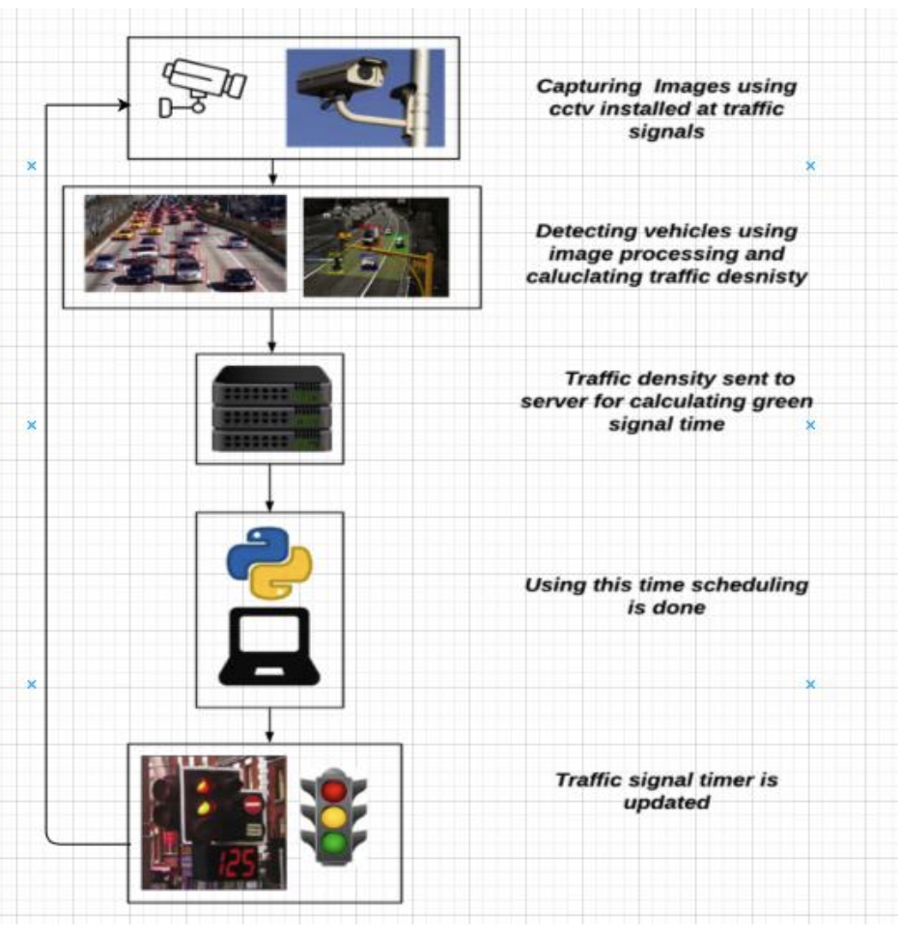

**Vehicle Detection Module**

Following are some images of the output of the Vehicle Detection Module:

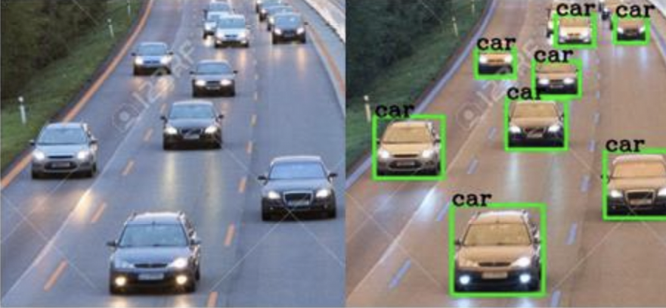

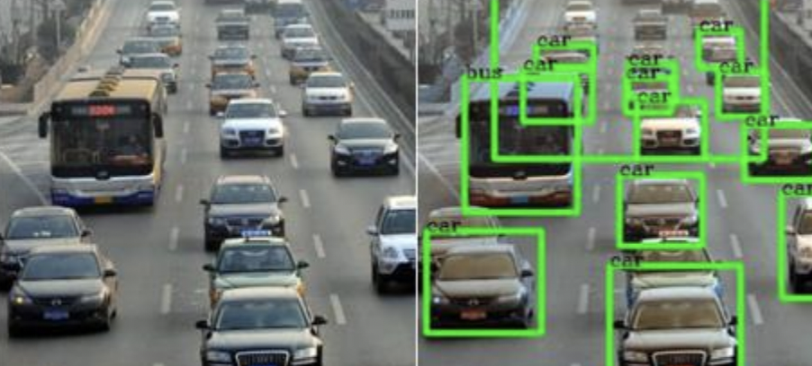

**Following are some images of the output of the Signal Switching Algorithm:**

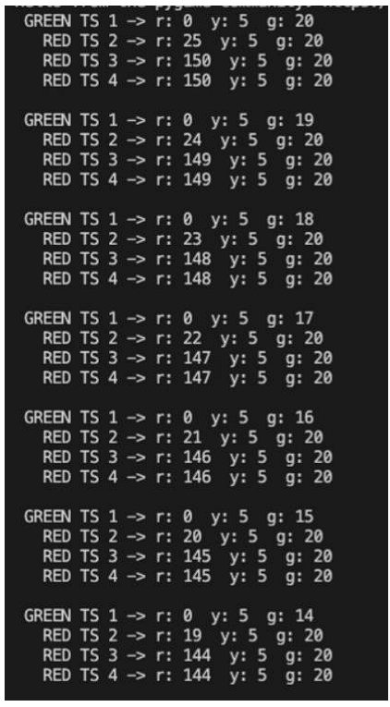

(i): Initially, all signals are loaded with default values, only the red signal time of the second signal is set according to green time and yellow time of first signal.

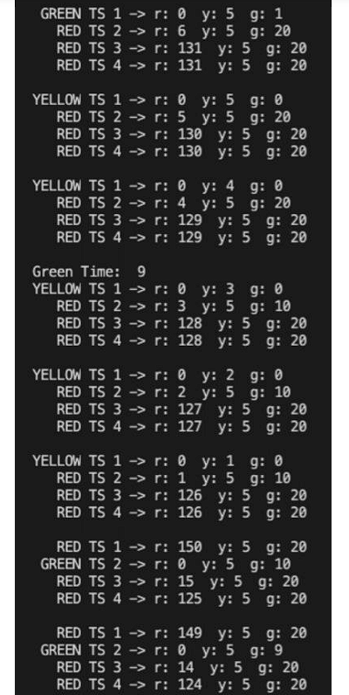

(ii): The leftmost column shows the status of the signal i.e. red, yellow, or green, followed by the traffic signal number, and the current red, yellow, and green timers of the signal. Here, traffic signal 1 i.e. TS 1 changes from green to yellow. As the yellow timer counts down, the results of the vehicle detection algorithm are calculated and a green time of 9 seconds is returned for TS 2. As this value is less than the minimum green time of 10, the green signal time of TS 2 is set to 10 seconds. When the yellow time of TS 1 reaches 0, TS 1 turns red and TS 2 turns green, and the countdown continues. The red signal time of TS 3 is also updated as the sum of yellow and green times of TS 2 which is 5+10=15.

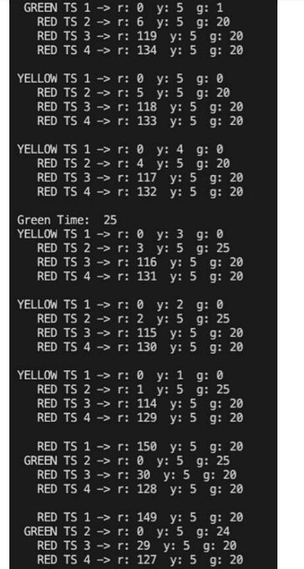

(iii): After a complete cycle, again, TS 1 changes from green to yellow. As the yellow timer counts down, the results of the vehicle detection algorithm are processed and a green time of 25 seconds is calculated for TS 2. As this value is more than the minimum green time and less than maximum green time, the green signal time of TS 2 is set to 25 seconds. When the yellow time of TS 1 reaches 0, TS 1 turns red and TS 2 turns green, and the countdown continues. The red signal time of TS 3 is also updated as the sum of yellow and green times of TS 2 which is 5+25=30.

**Simulation Module**

Following are some images of the final simulation:

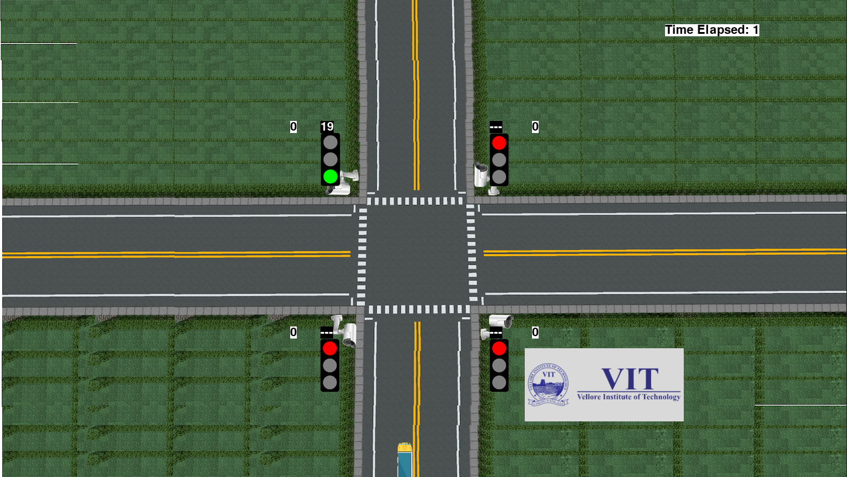

(i): Simulation just after start showing red and green lights, green signal time counting down from a default of 20 and red time of next signal blank. When the signal is red, we display a blank value till it reaches 10 seconds. The number of vehicles that have crossed can be seen beside the signal, which are all 0 initially. The time elapsed since the start of simulation can be seen on top right.

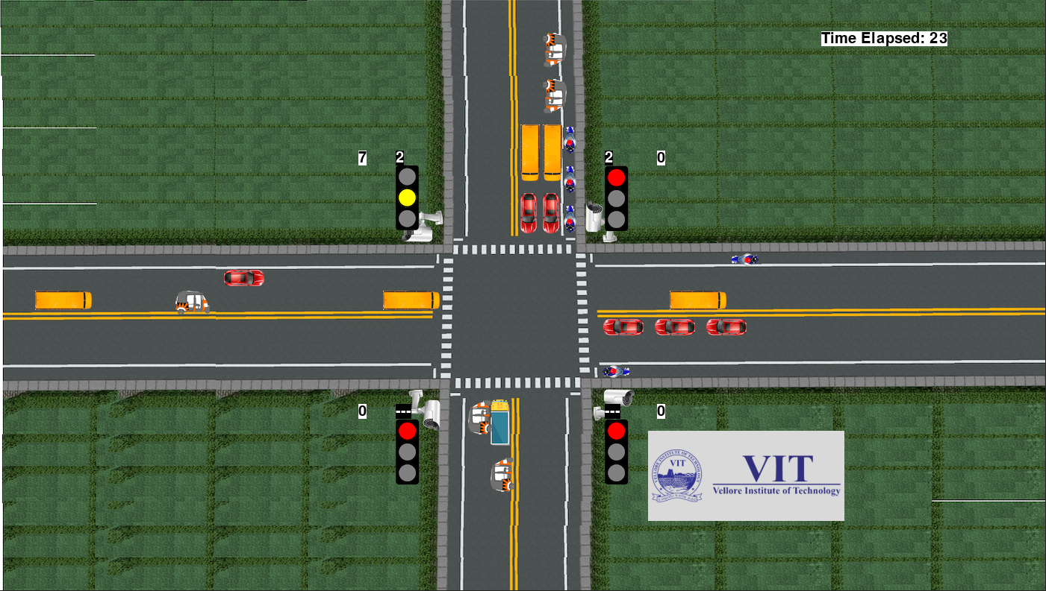

(ii): Simulation showing yellow light and red time for next signal. When red signal time is less than 10 seconds, we show the countdown timer so that vehicles can start up and be prepared to move once the signal turns green.

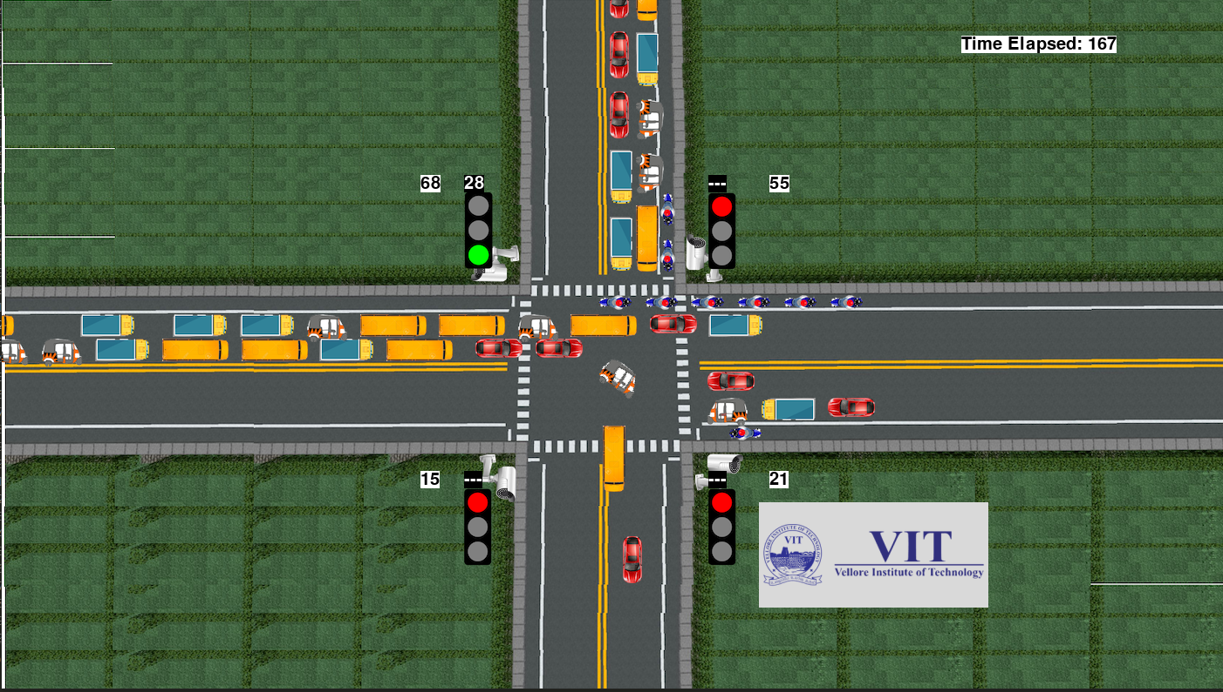

(iii): Simulation showing vehicles turning

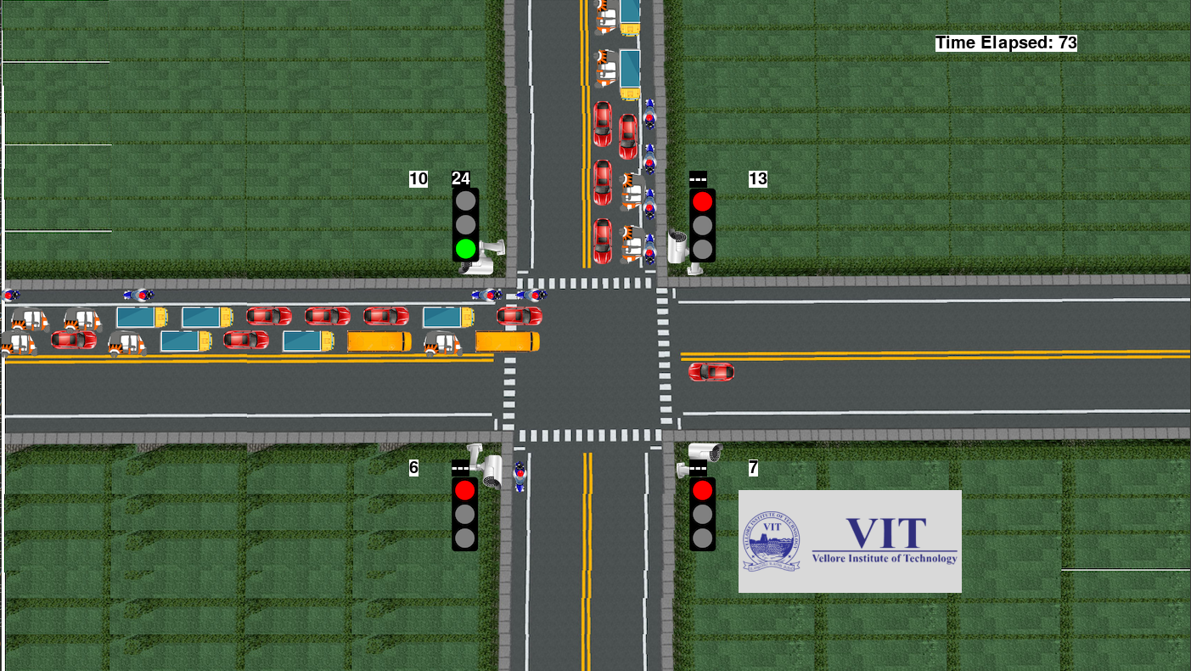

(iv): Simulation showing green time of signal for vehicles moving up set to 10 seconds according to the vehicles in that direction. As we can see, the number of vehicles is quite less here as compared to the other lanes. With the current static system, the green signal time would have been the same for all signals, like 30 seconds. But in this situation, most of this time would have been wasted. But our adaptive system detects that there are only a few vehicles, and sets the green time accordingly, which is 10 seconds in this case

MODEL SIMULATION

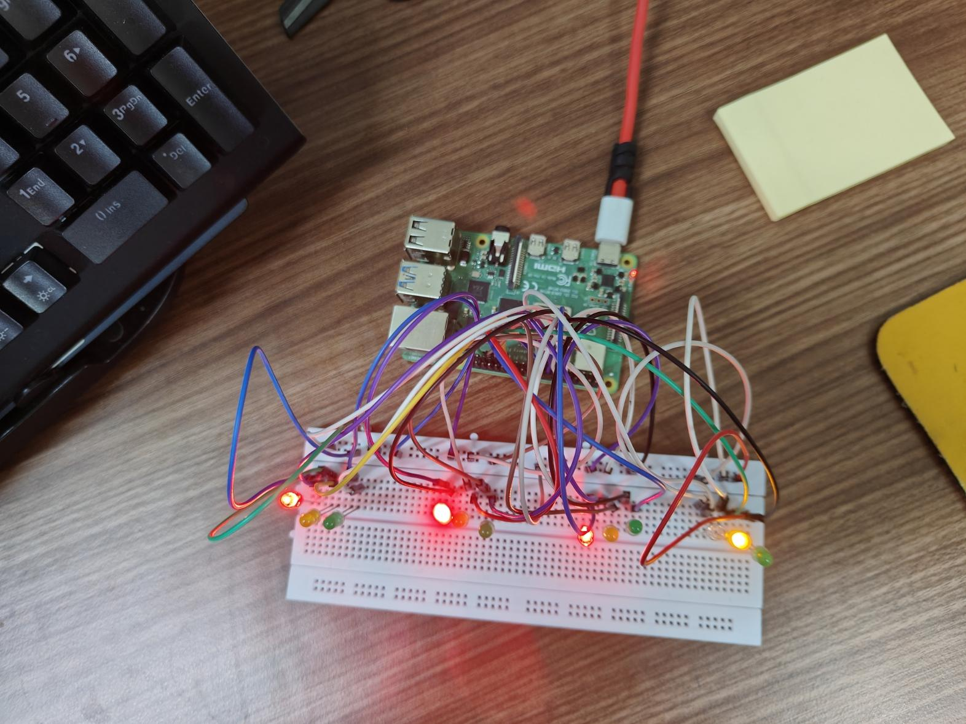

Raspberry PI

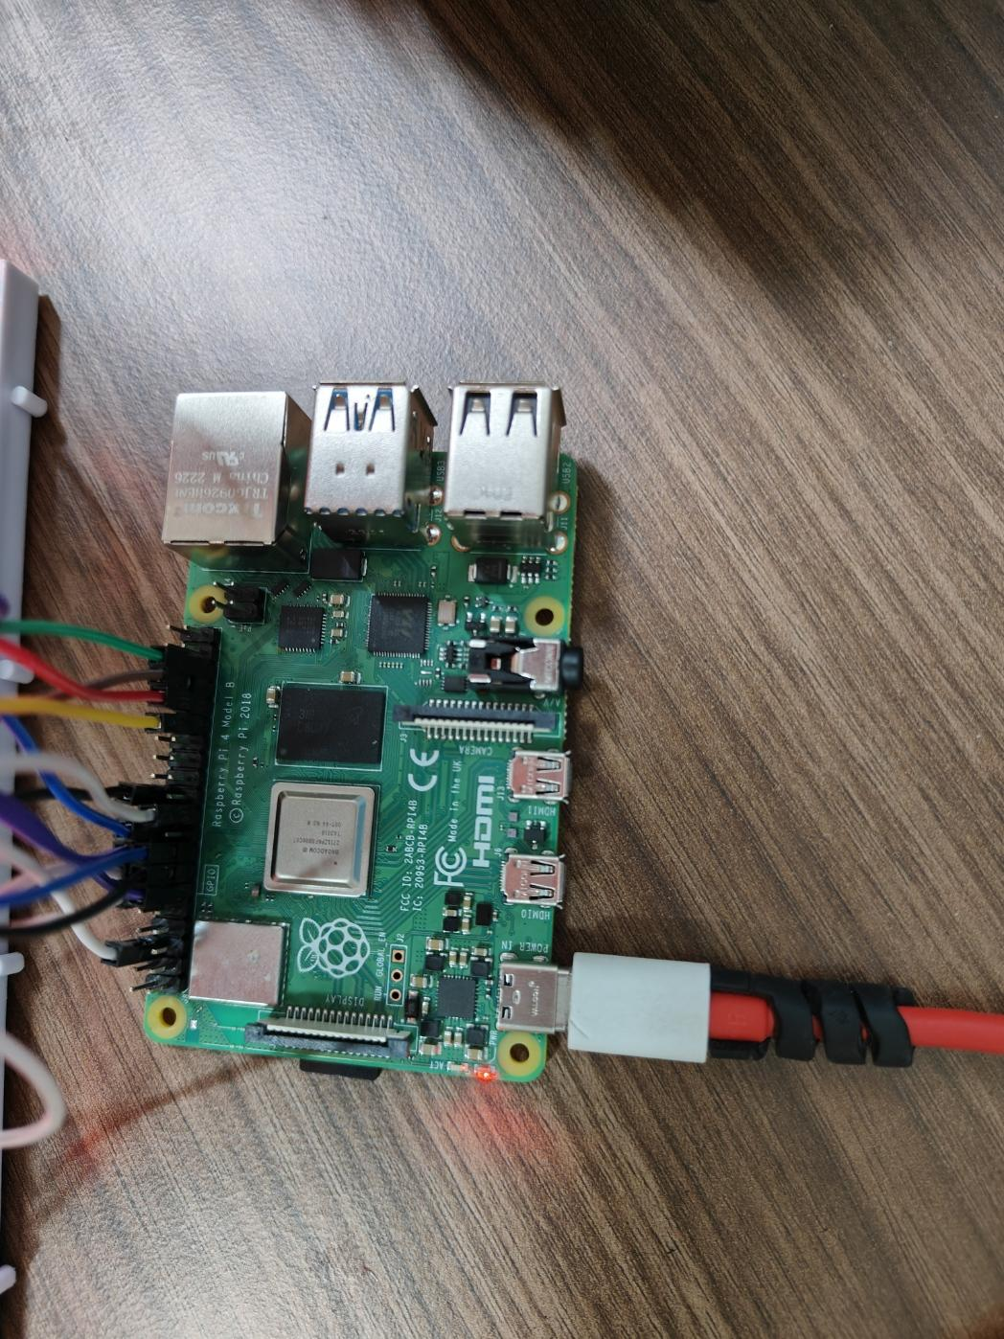

Connection between breadboard and raspberry pi

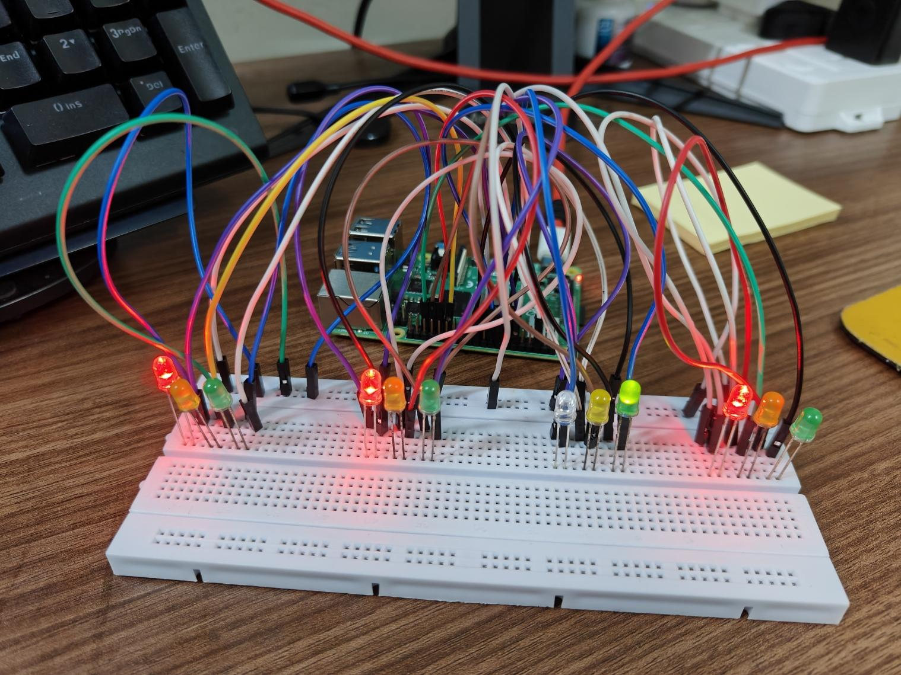

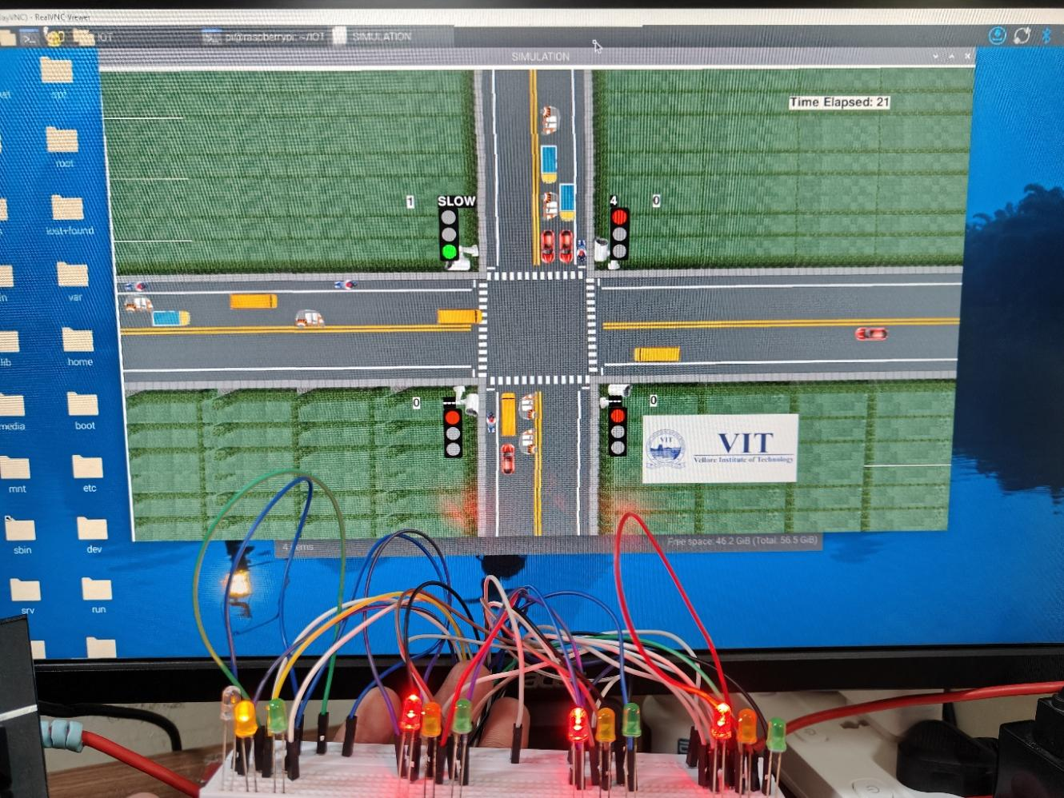

**Circuit Diagram**

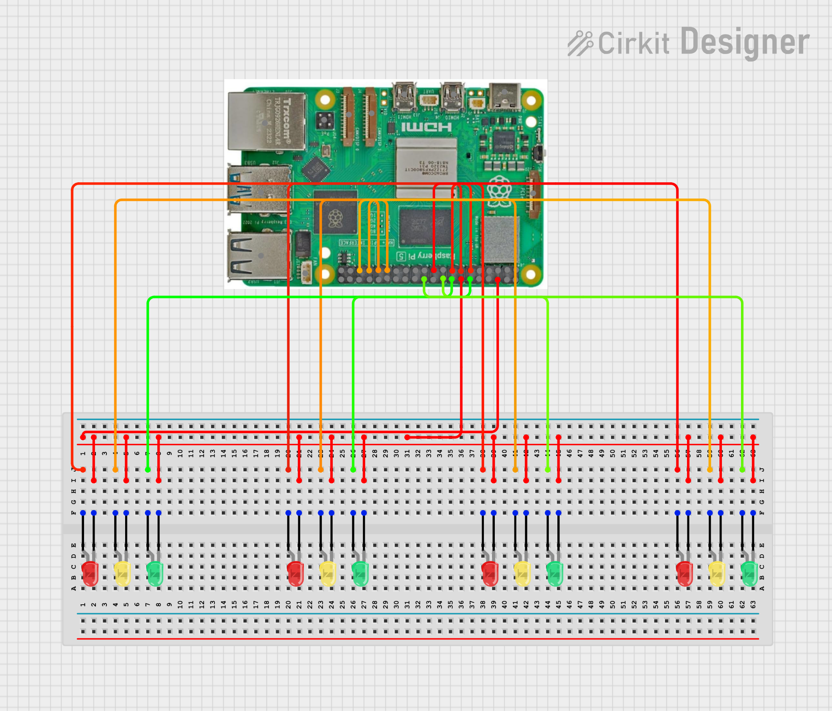

**7.Code Explanation**  
  
1. Import necessary libraries for GPIO, threading, math, pygame, and other utilities.

2. Define configurations:

- Set GPIO pins for traffic lights (RED, YELLOW, GREEN).

- Set default times for signals and parameters for vehicle detection and movement.

3. Define global variables:

- Manage the state of signals, vehicle count, direction, lanes, and simulation time.

4. Initialize GPIO:

- Set GPIO mode and configure pins for output to control LEDs.

5. Define a `TrafficSignal` class:

- Store and manage signal durations (red, yellow, green) with minimum and maximum values.

6. Define a `Vehicle` class:

- Represent vehicles with attributes for lane, type, speed, direction, position, and image.

- Implement methods for rendering and moving vehicles based on traffic flow.

7. Define helper functions:

- `gpio_init()`: Initialize GPIO pins.

- `control_traffic_lights()`: Control LEDs based on the current signal state.

- `initialize()`: Initialize traffic signals and manage simulation.

- `setTime()`: Dynamically adjust green signal time based on vehicle density.

- `repeat()`: Manage the transition between green, yellow, and red signals.

- `printStatus()`: Display the current state of traffic signals.

- `updateValues()`: Update signal timers every second.

- `generateVehicles()`: Simulate vehicle arrival at the intersection.

- `simulationTime()`: Track and display simulation runtime statistics.

8. Define a `Main` class:

- Initialize GPIO and start simulation threads for:

a. Simulation time tracking.

b. Vehicle generation.

c. Signal initialization and management.

- Configure the simulation environment using `pygame`:

- Load and display intersection background.

- Load and display signal and vehicle images.

- Update vehicle movement and signal states dynamically.

- Handle `pygame` events to allow program termination.

9. Start the simulation loop:

- Continuously update the simulation display, process events, and manage traffic flow.

10. Exit the program:

- Clean up GPIO and terminate simulation when the runtime is complete.

**8.Adaptive Timer Code**

***# Set time according to formula***

**def setTime():**

**global noOfCars, noOfBikes, noOfBuses, noOfTrucks, noOfRickshaws, noOfLanes**

**global carTime, busTime, truckTime, rickshawTime, bikeTime**

**os.system(**

**"say detecting vehicles, " + directionNumbers[(currentGreen + 1) % noOfSignals]**

**)**

**noOfCars, noOfBuses, noOfTrucks, noOfRickshaws, noOfBikes = 0, 0, 0, 0, 0**

**for j in range(len(vehicles[directionNumbers[nextGreen]][0])):**

**vehicle = vehicles[directionNumbers[nextGreen]][0][j]**

**if vehicle.crossed == 0:**

**vclass = vehicle.vehicleClass**

***# print(vclass)***

**noOfBikes += 1**

**for i in range(1, 3):**

**for j in range(len(vehicles[directionNumbers[nextGreen]][i])):**

**vehicle = vehicles[directionNumbers[nextGreen]][i][j]**

**if vehicle.crossed == 0:**

**vclass = vehicle.vehicleClass**

***# print(vclass)***

**if vclass == "car":**

**noOfCars += 1**

**elif vclass == "bus":**

**noOfBuses += 1**

**elif vclass == "truck":**

**noOfTrucks += 1**

**elif vclass == "rickshaw":**

**noOfRickshaws += 1**

***# print(noOfCars)***

**greenTime = math.ceil(**

**(**

**(noOfCars * carTime)**

**+ (noOfRickshaws * rickshawTime)**

**+ (noOfBuses * busTime)**

**+ (noOfTrucks * truckTime)**

**+ (noOfBikes * bikeTime)**

**)**

**/ (noOfLanes + 1)**

**)**

***# greenTime = math.ceil((noOfVehicles)/noOfLanes)***

**print("Green Time: ", greenTime)**

**if greenTime < defaultMinimum:**

**greenTime = defaultMinimum**

**elif greenTime > defaultMaximum:**

**greenTime = defaultMaximum**

**signals[(currentGreen + 1) % (noOfSignals)].green = greenTime**

## **9. References**

1. Smith, J., & Doe, R. (2022). *Machine Learning for Traffic Optimization*. Journal of Smart Cities, 45(3), 123-134.
2. Kumar, P., & Sharma, A. (2021). *IoT-Based Adaptive Traffic Management System*. International Journal of IoT, 12(4), 89-100.
3. Zhang, L. (2020). *Reinforcement Learning for Dynamic Traffic Control*. IEEE Transactions on Intelligent Transportation Systems, 21(7), 567-576.